

**December 1, 2024 – Advent 1 (C)**

**First Week of Advent: Saying “Yes” to the Journey**

As Advent begins this week, we invite you to orient yourself to the coming of Jesus at Christmas through the practices of *Journeying the Way of Love*. This journey begins by saying “yes” to God’s call to birth new life into the world—a call that is both powerful and gentle, a call that will, if fully embraced, grow beyond our imaginations, spilling out of ourselves and into our family, friends, community, and the whole world. Over the course of this holy season, we invite you to respond to that call using these daily practices, and encourage you to offer them to your friends, family, and neighbors.

For more Advent resources related to the Way of Love, visit episcopalchurch.org/wayoflove. There, you’ll find links to the full Advent curriculum *Journeying the Way of Love*, as well as *Living the Way of Love in Community,* a nine-session curriculum for use anytime.

**Sunday, December 1**

**WORSHIP**

Read Luke 21:25-36. How do the symbols of the Advent season help you understand the story of Jesus? Where do you see them in your worship today?

**Monday, December 2**

**PRAY**

Pray along with the Collect for Advent 1, found on page 211 of The Book of Common Prayer. Set a timer for three minutes to sit in silence and hear what God might be saying back to you.

**Tuesday, December 3**

**TURN**

Read Isaiah 58. How does this reading challenge you to think about feasts and festivals di­fferently? How might this lesson change the way you celebrate or recognize this holy season?

**Wednesday, December 4**

**BLESS**

Call or write a letter to a family member with whom you would like to have a closer relationship. Make plans in the new year to chat on the phone or meet over Zoom or in person. Let them know how much you love them and look forward to knowing them better.

**Thursday, December 5**

**REST**

Put your phone on airplane mode and leave it in a dresser drawer for an hour or two. Whatever happens in that time, you can handle later. Give this time to yourself and Jesus, to rest and recharge for the week ahead.

**Friday, December 6**

**GO**

Go out into your neighborhood today. Where is God at work? Ask God to show you how you can celebrate that good work and name God’s presence in your community.

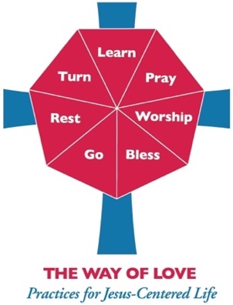**Saturday, December 7**

**LEARN**

Read Luke 1:59-80. When Zechariah’s speech returns, he praises God. If you lost the power to speak for nine months like Zechariah did, what would be your first word of praise? Share this with your family, friends, and on social media.