

November 17, 2024 – Pentecost 26 (B)
Presiding Bishop Sean W. Rowe Investiture

Episcopalians around the world and in various time zones gathered to welcome the Most Rev. Sean Rowe as the church’s 28th presiding bishop in a first-of-its-kind virtual investiture service, livestreamed Nov. 2 from the Chapel of Christ the Lord at The Episcopal Church Center in New York City.

Rowe, formerly bishop of the Episcopal Dioceses of Northwestern Pennsylvania and Western New York, was elected and confirmed as the next presiding bishop at the 81st General Convention on June 26.

Soon after his election, Bishop Rowe requested a simpler, scaled-down ceremony of Holy Eucharist and Investiture to encourage wider church engagement and reduce carbon footprint. A limited number of in-person attendees participated from inside the chapel.

The rich diversity within the multinational Episcopal Church was highlighted in several ways. A special “roll call” preceding the 11 a.m. ET ceremony featured video greetings from many of the church’s 106 dioceses. Water gathered from various provinces of the church was combined in the baptismal font. The Litany for the Mission of the Church

November 17, 2024 – Pentecost 26 (B)
Presiding Bishop Sean W. Rowe Investiture

Episcopalians around the world and in various time zones gathered to welcome the Most Rev. Sean Rowe as the church’s 28th presiding bishop in a first-of-its-kind virtual investiture service, livestreamed Nov. 2 from the Chapel of Christ the Lord at The Episcopal Church Center in New York City.

Rowe, formerly bishop of the Episcopal Dioceses of Northwestern Pennsylvania and Western New York, was elected and confirmed as the next presiding bishop at the 81st General Convention on June 26.

Soon after his election, Bishop Rowe requested a simpler, scaled-down ceremony of Holy Eucharist and Investiture to encourage wider church engagement and reduce carbon footprint. A limited number of in-person attendees participated from inside the chapel.

The rich diversity within the multinational Episcopal Church was highlighted in several ways. A special “roll call” preceding the 11 a.m. ET ceremony featured video greetings from many of the church’s 106 dioceses. Water gathered from various provinces of the church was combined in the baptismal font. The Litany for the Mission of the Church
featured 15 intercessors who shared prayers in the following languages: Eastern Shoshone, Mandarin, Juba, German, Arabic, Hebrew, French, Anishinaabemowin, Spanish, English, French, and Xhosa.

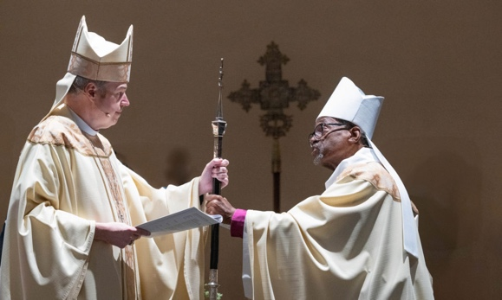
The Rt. Rev. Michael Curry, who served as the church’s 27th presiding bishop from 2015-2024, presided over the first half of the service, which included a land acknowledgment from the Rt. Rev. Katharine Jefferts Schori, who served as 26th presiding bishop; a welcome from diocesan and investiture committee representatives and House of Deputies President Julia Ayala Harris; the renewal of baptismal vows; and the presentation of the primatial staff. Bishop Jefferts Schori joined youth presentative Maya Lattimer in offering prayers for the new presiding bishop, whom Bishop Curry presented along with Bishop Rowe’s family.

Bishop Rowe presided over the service of Holy Eucharist and delivered a sermon based on the Gospel passage of John 11:32-44. “I believe that it is in our gathered communities across our church where we come closest to glimpsing the real power of the story of Lazarus,” he said. “Every time we feed the hungry, care for the sick, and welcome the stranger, we are reaching for life in the face of death. As we baptize and bury God’s people, as we make disciples and proclaim the gospel, as we soothe the suffering and shield the joyous, we are unbinding our congregations and setting our hurting world free.” Find links to the recorded service; worship service booklet; Bishop Rowe’s sermon; and more at iam.ec/investiture.

featured 15 intercessors who shared prayers in the following languages: Eastern Shoshone, Mandarin, Juba, German, Arabic, Hebrew, French, Anishinaabemowin, Spanish, English, French, and Xhosa.

The Rt. Rev. Michael Curry, who served as the church’s 27th presiding bishop from 2015-2024, presided over the first half of the service, which included a land acknowledgment from the Rt. Rev. Katharine Jefferts Schori, who served as 26th presiding bishop; a welcome from diocesan and investiture committee representatives and House of Deputies President Julia Ayala Harris; the renewal of baptismal vows; and the presentation of the primatial staff. Bishop Jefferts Schori joined youth presentative Maya Lattimer in offering prayers for the new presiding bishop, whom Bishop Curry presented along with Bishop Rowe’s family.

Bishop Rowe presided over the service of Holy Eucharist and delivered a sermon based on the Gospel passage of John 11:32-44. “I believe that it is in our gathered communities across our church where we come closest to glimpsing the real power of the story of Lazarus,” he said. “Every time we feed the hungry, care for the sick, and welcome the stranger, we are reaching for life in the face of death. As we baptize and bury God’s people, as we make disciples and proclaim the gospel, as we soothe the suffering and shield the joyous, we are unbinding our congregations and setting our hurting world free.” Find links to the recorded service; worship service booklet; Bishop Rowe’s sermon; and more at iam.ec/investiture.

