

October 20, 2024 – Pentecost 22 (B)
Evangelism Grants

Episcopal institutions are invited to apply for evangelism grants (iam.ec/evangelismgrants) to support local and regional efforts to grow Episcopal ministries, resources, and gatherings—and to energize the church to share and celebrate the Good News of Jesus Christ. The application deadline is Oct. 28.

The grant application, criteria, requirements, budget information, and more are available online in English, Spanish, and French.

The grants committee will consider proposals for up to $2,000 for individual faith communities and up to $8,000 for multichurch, diocesan, provincial, and other regional collaborations. A total of $125,000 is available for this funding cycle.

The 2024 grant focus is on evangelism initiatives that minister across barriers. Projects that would fit this theme include the following:
- Collaborative, lay-led ministries that are not clergy dependent.

October 20, 2024 – Pentecost 22 (B)
Evangelism Grants

Episcopal institutions are invited to apply for evangelism grants (iam.ec/evangelismgrants) to support local and regional efforts to grow Episcopal ministries, resources, and gatherings—and to energize the church to share and celebrate the Good News of Jesus Christ. The application deadline is Oct. 28.

The grant application, criteria, requirements, budget information, and more are available online in English, Spanish, and French.

The grants committee will consider proposals for up to $2,000 for individual faith communities and up to $8,000 for multichurch, diocesan, provincial, and other regional collaborations. A total of $125,000 is available for this funding cycle.

The 2024 grant focus is on evangelism initiatives that minister across barriers. Projects that would fit this theme include the following:
- Collaborative, lay-led ministries that are not clergy dependent.
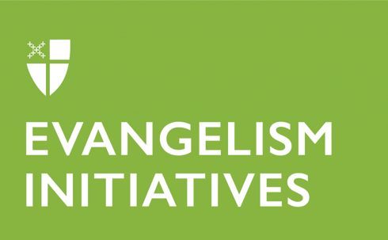
- Ministries that explicitly support and include communities traditionally underrepresented in The Episcopal Church.
- Ministries that engage new ways of being the church in new spaces.

Grants were awarded to 22 projects during the 2023 funding cycle. Funded projects included:
- Creating Space in New Spaces, Episcopal Diocese of Kansas
- Encuentros con Jesús en El Trabajo Agrícola, Episcopal Diocese of Ecuador Litoral
- Episco-PRIDE, Episcopal Diocese of Iowa
- Hispanic Ministries Evangelism Project, Episcopal Church in Southeast Florida
- Latino/Hispanic Bilingual Camp, Episcopal Diocese of Western North Carolina
- Dove Faith Cafe Podcast, Episcopal Diocese of Northern Indiana
- Imagine Cincinnati: Nature-Based, Liturgically Rooted Worship for Families, Episcopal Diocese of Southern Ohio
- Neighbor to Neighbor Evangelism, Episcopal Diocese of Alabama
- Relationship Evangelism, Episcopal Diocese of Los Angeles
- Ministries that explicitly support and include communities traditionally underrepresented in The Episcopal Church.
- Ministries that engage new ways of being the church in new spaces.

Grants were awarded to 22 projects during the 2023 funding cycle. Funded projects included:
- Creating Space in New Spaces, Episcopal Diocese of Kansas
- Encuentros con Jesús en El Trabajo Agrícola, Episcopal Diocese of Ecuador Litoral
- Episco-PRIDE, Episcopal Diocese of Iowa
- Hispanic Ministries Evangelism Project, Episcopal Church in Southeast Florida
- Latino/Hispanic Bilingual Camp, Episcopal Diocese of Western North Carolina
- Dove Faith Cafe Podcast, Episcopal Diocese of Northern Indiana
- Imagine Cincinnati: Nature-Based, Liturgically Rooted Worship for Families, Episcopal Diocese of Southern Ohio
- Neighbor to Neighbor Evangelism, Episcopal Diocese of Alabama
- Relationship Evangelism, Episcopal Diocese of Los Angeles

