January 7, 2024 – Epiphany 1 (B)
Baptism of Our Lord

The Feast of the Baptism of Our Lord is celebrated each year on the Sunday following the Feast of the Epiphany on January 6. The event of Christ’s baptism is recorded in all four gospel accounts:

“In those days Jesus came from Nazareth of Galilee and was baptized by John in the Jordan. And just as he was coming up out of the water, he saw the heavens torn apart and the Spirit descending like a dove on him. And a voice came from heaven, ‘You are my Son, the Beloved; with you I am well pleased’” (Mark 1:9-11).

“Now when all the people were baptized, and when Jesus also had been baptized and was praying, the heaven was opened, and the Holy Spirit descended upon him in bodily form like a dove. And a voice came from heaven, ‘You are my Son, the Beloved; with you I am well pleased’” (Luke 3:21-22).

“The next day he saw Jesus coming towards him and declared, ‘Here is the Lamb of God who takes away the sin of the world! This is he of whom I said, “After me comes a man who ranks ahead of me because he was before me.” I myself did not know him; but I came baptizing with water for this reason, that he might be revealed to Israel.’ And John testified, ‘I saw the Spirit descending from heaven like a dove, and it remained on him. I myself did not know him, but the one who sent me to baptize with water said to me, “He on whom you see the Spirit descend and remain is the one who baptizes with the Holy Spirit.” And I myself have seen and have testified that this is the Son of God’” (John 1:29-34).
Detail from 13th-century fresco above baptismal font, Zica monastery, near Kraljevo, Serbia.
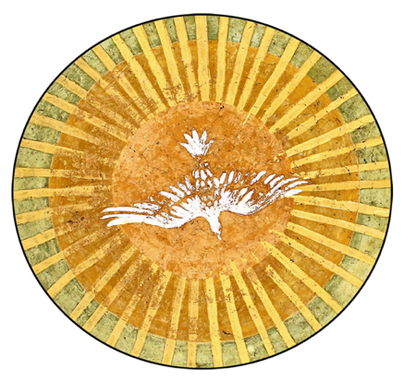
“Then Jesus came from Galilee to John at the Jordan, to be baptized by him. John would have prevented him, saying, ‘I need to be baptized by you, and do you come to me?’ But Jesus answered him, ‘Let it be so now; for it is proper for us in this way to fulfill all righteousness.’ Then he consented. And when Jesus had been baptized, just as he came up from the water, suddenly the heavens were opened to him and he saw the Spirit of God descending like a dove and alighting on him. And a voice from heaven said, ‘This is my Son, the Beloved, with whom I am well pleased’” (Matthew 3:13-17).

