December 10, 2023 – Advent 2 (B)
Second Week of Advent: Journeying with Family and Friends

As we continue our Advent walk, we invite you to see the Way of Love as a journey that can expand to include family and friends. Mary said “yes” to the call to birth Jesus, God’s Word, into the world and immediately went in haste to share her good news with her cousin, Elizabeth—a four-day journey into the Judean hills. Isn’t that what happens when we hear good news? We are driven to go and tell others. The Way of Love is good news that demands to be shared.

For more Advent resources related to the Way of Love, visit episcopalchurch.org/wayoflove. There, you’ll find links to the full Advent curriculum Journeying the Way of Love, as well as Living the Way of Love in Community, a nine-session curriculum for use anytime.

Sunday, December 10
WORSHIP
Read Luke 3:1-6. How does the story of John the Baptist fill your heart with hope?

Monday, December 11
TURN
Turn away from the busyness of the world right now. Turn your heart and mind toward giving thanks for this time of reflection, refreshment, and renewal.

December 10, 2023 – Advent 2 (B)
Second Week of Advent: Journeying with Family and Friends

As we continue our Advent walk, we invite you to see the Way of Love as a journey that can expand to include family and friends. Mary said “yes” to the call to birth Jesus, God’s Word, into the world and immediately went in haste to share her good news with her cousin, Elizabeth—a four-day journey into the Judean hills. Isn’t that what happens when we hear good news? We are driven to go and tell others. The Way of Love is good news that demands to be shared.

For more Advent resources related to the Way of Love, visit episcopalchurch.org/wayoflove. There, you’ll find links to the full Advent curriculum Journeying the Way of Love, as well as Living the Way of Love in Community, a nine-session curriculum for use anytime.

Sunday, December 10
WORSHIP
Read Luke 3:1-6. How does the story of John the Baptist fill your heart with hope?

Monday, December 11
TURN
Turn away from the busyness of the world right now. Turn your heart and mind toward giving thanks for this time of reflection, refreshment, and renewal.

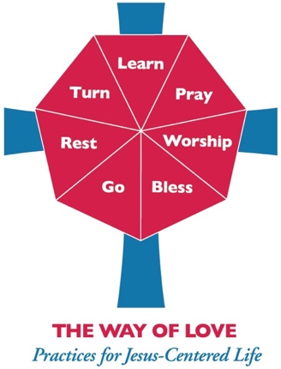
Tuesday, December 12
LEARN
Read Luke 1:45. Share your faith story with one new person this week. It can be someone you have known for a while who has not heard the faith part of your story.
Wednesday, December 13
PRAY
Pray along with the Collect for Advent 2, found on page 211 of The Book of Common Prayer. As you are out and about for the rest of this week, notice the people you pass. Ask God to bless them in their lives and work. See how this changes the way you go about your week.

Thursday, December 14
BLESS
Spend a significant amount of time today discerning if there is a special blessing or gift you can share with your church, a local ministry, or with your community. Ask God to inspire and equip you with the fortitude and tools to make this gift something truly memorable and heartfelt.

Friday, December 15
GO
Go out of your way to have a conversation with someone you might not normally visit with today. Ask God to open your heart to hear this person as God does.

Saturday, December 16
REST
Put your phone on airplane mode and leave it in a dresser drawer for an hour or two. Whatever happens in that time, you can handle later. Give this time to yourself and Jesus, to rest and recharge for the week ahead.
Tuesday, December 12
LEARN
Read Luke 1:45. Share your faith story with one new person this week. It can be someone you have known for a while who has not heard the faith part of your story.
Wednesday, December 13
PRAY
Pray along with the Collect for Advent 2, found on page 211 of The Book of Common Prayer. As you are out and about for the rest of this week, notice the people you pass. Ask God to bless them in their lives and work. See how this changes the way you go about your week.

Thursday, December 14
BLESS
Spend a significant amount of time today discerning if there is a special blessing or gift you can share with your church, a local ministry, or with your community. Ask God to inspire and equip you with the fortitude and tools to make this gift something truly memorable and heartfelt.

Friday, December 15
GO
Go out of your way to have a conversation with someone you might not normally visit with today. Ask God to open your heart to hear this person as God does.

Saturday, December 16
REST
Put your phone on airplane mode and leave it in a dresser drawer for an hour or two. Whatever happens in that time, you can handle later. Give this time to yourself and Jesus, to rest and recharge for the week ahead.

