April 30, 2023 – Easter 4 (A)
Week 4: Reflections on the Resurrection

During the Easter season, Sermons That Work is pleased to present reflections from some of the newest bishops of The Episcopal Church on the resurrection of our Lord. Check back each week for a brief exploration of how Jesus Christ’s rising from the grave changes everything. To listen to this reflection, scan the QR code on this page and subscribe to the Sermons That Work podcast.

Mary Magdalene, Joanna, Mary the mother of James, and the other women who were with them; these women are not only the first evangelists, but they are also the saints we need for our day.

They do not yet know what it will look like or what it will mean that Jesus is risen from the dead. They do not know, at this point in the story, how it will be that Jesus will reveal himself to them, in what form he will appear, how they will know, or what it will look like. They do not yet know where new life is, only where old life is no longer.

But they do not wait. They do not need to know what comes next in order to proclaim what currently is. These women stand in the midst of an empty tomb and see it filled with the potential that Jesus is very much alive; not as he had been, but as he will be. These women do not hold back from proclaiming their truth to those who would disbelieve. They did not care that it would not make sense, that others could not yet see what they had seen.

This is a critical moment for these women and the rest of Jesus’ followers. The scenes that follow -- the post-resurrection appearances of Jesus -- are dependent on them knowing the possibility that Jesus might just appear. If they could not consider the angels’ words, if they could not hold out hope that the tomb could not contain the love of God, they could never have known resurrection when it appeared. Jesus could not be on the beach, grilling fish, if he were back in the tomb. He could not be walking with them on the road to Emmaus, if his body were someplace else unknown.

In order for them to see the fullness of God’s Love in the world around them, they needed to see the emptiness of the tomb. They needed to stop looking for the living among the dead and instead seek the living Christ in the life of the world. These women are our evangelists, proclaiming to us the Good News that Jesus Christ is risen.

These women are our saints - our inspiration and our example of how it is God asks us to stop seeking the living among the dead. To stop seeking life at the empty tombs of our lives. To allow for the potential that new life is around every corner, a possibility that exists only when we stop insisting it can only be found where it once was.

We do not need to know where it is that the Risen Life of Christ will meet us on the roads of our lives. We need only know that the empty tomb we are in is not, in fact, empty, but full. It is full of possibilities. It is full of hope. It is full of love. It is full of life.

Why do you seek the living among the dead?

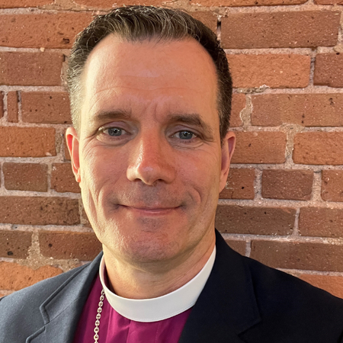
Alleluia! Christ is risen!
The Lord is risen indeed! Alleluia!

The Rt. Rev. Jeffrey W. Mello is the sixteenth Bishop Diocesan for the Episcopal Church in Connecticut. Bishop Mello was consecrated in October 2022.

