August 28, 2022 – Pentecost 12 (C)

Gifts to the Church by Episcopal Convents and Monasteries:

The Community of St. Francis

The Community of St. Francis describes being present to people suffering homelessness.

The Homelessness Crisis
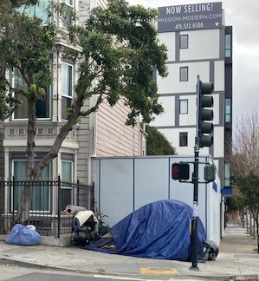
Homelessness is an urgent and challenging social issue of our time. The big cities get most of the media attention, but there are unhoused people in rural and suburban areas as well. Nationally, there are over half a million chronically homeless people. Homelessness is complicated, since it is interconnected with low wages, lack of affordable housing, poverty, inequality, addiction, and mental health issues. Homelessness is more than being unhoused, so “homeless” is actually more descriptive than the more politically correct “unhoused,” which doesn’t evoke the alienation, the isolation, the lack of privacy, the loss of possessions, the mental, emotional, and spiritual anguish of being without a home. These are people with stories we need to hear. Homelessness is less about personal flaws than it is about the flaws in our social system. See www.invisiblepeople.tv.

The Church and Homelessness
Our Baptismal Vows call us to serve Christ in all persons and to respect the dignity of every human being. The Five Marks of Mission, adopted by the Anglican Consultative Council, include responding to human need by loving service and seeking to transform unjust structures of society. Our church belongs in the midst of the homeless community. In San Francisco, many of the services for the unhoused are associated with The Episcopal Church: shelters, permanent supportive housing, food, job training, and counseling. One local church opens its doors for safe sleep in their sanctuary weekday mornings.

Franciscans and the Marginalized
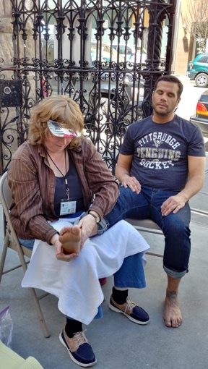
St. Francis of Assisi ministered to the marginalized, especially the outcast lepers in his day, and Franciscans for 800 years have continued this tradition. The Sisters of the Community of St. Francis (www.communitystfrancis.org) have almost 50 years of experience of being with people suffering homelessness in San Francisco. We have helped with several homeless feeding programs, especially a local Catholic Worker House of Hospitality. We have been part of the Ecclesia Ministry Open Cathedral as worshippers and cooks. We have offered chair massages at various social agencies and, on Maundy Thursday, foot massages on the streets to our homeless neighbors.

You, too, can get involved. Check out what is happening in your local area. You can also help with the work of advocacy on behalf of people suffering homelessness through ministries like the Episcopal Public Policy Network (iam.ec/eppn). Learn more about the Community of St. Francis at www.communitystfrancis.org.

