December 5, 2021 – Advent 2 (C)
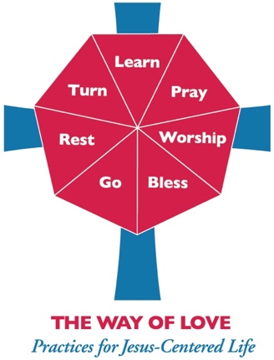
Second Week of Advent: Journeying with Family and Friends

As we continue our Advent walk, we invite you to see the Way of Love as a journey that can expand to include family and friends. Mary said “yes” to the call to birth Jesus, God’s Word, into the world and immediately went in haste to share her good news with her cousin, Elizabeth—a four-day journey into the Judean hills. Isn’t that what happens when we hear good news? We are driven to go and tell others. The Way of Love is good news that demands to be shared.

For more Advent resources related to the Way of Love, visit episcopalchurch.org/wayoflove. There, you’ll find links to the full Advent curriculum Journeying the Way of Love, as well as Living the Way of Love in Community, a nine-session curriculum for use anytime.

Sunday, December 5
WORSHIP
Read Luke 3:1-6. How does the story of John the Baptist fill your heart with hope?

Monday, December 6
GO
Read or watch your local news. Ask God to open your heart and eyes to ways you can promote reconciliation and healing in your community.

Tuesday, December 7
LEARN
Read Luke 1:45. Share your faith story with one new person this week. It can be someone you have known for a while who has not heard the faith part of your story.
Wednesday, December 8
PRAY
Pray along with the Collect for Advent 2, found on page 211 of The Book of Common Prayer. As you are out and about for the rest of this week, notice the people you pass. Ask God to bless them in their lives and work. See how this changes the way you go about your week.

Thursday, December 9
BLESS
Call or write a letter to a family member with whom you would like to have a closer relationship. Make plans in the new year to chat on the phone or meet over Zoom or in person. Let them know how much you love them and look forward to knowing them better.

Friday, December 10
TURN
Where did you struggle this week? Do you have amends or apologies or adjustments you need to make? Ask God to open your heart and mind to those opportunities for reconciliation and growth. Thank God for the gifts of mercy and love, and the courage to make the changes necessary. And then do your best, with God’s help, to make those changes.

Saturday, December 11
REST
Set aside 30 minutes to spend in silence with your best friend today. Sure, it may feel a little weird to be silent on the phone or while sitting next to each other on the couch or across the table. Just give it a try. Make sure to set aside time after your silence to pray for each other and to say thanks for the time of rest.

