

March 2, 2025 – Last Sunday in Epiphany (C)
What Is Lent?

Today is the last Sunday in the season of Epiphany. In just a few days, the church will begin observing Lent. Ash Wednesday falls on March 5 this year, and marks the beginning of the season of Lent, the 40-day period before Easter.

The period of 40 days, which traditionally does not include Sundays, commemorates the “40 days and 40 nights” (Matthew 4:2) that Jesus fasted in the desert and then resisted temptations from Satan.

The word “Lent” comes from an Old English word for “spring,” and is derived from the German word “lang,” meaning “long,” because during this season before Easter, the hours of daylight become longer.

The Book of Common Prayer explains Lent in this way: “The first Christians observed with great devotion the days of our Lord’s passion and resurrection, and it became the custom of the Church to prepare for them by a season of penitence and fasting. This season of Lent provided a time in which converts to the faith were prepared for Holy Baptism. It was also a time

March 2, 2025 – Last Sunday in Epiphany (C)
What Is Lent?

Today is the last Sunday in the season of Epiphany. In just a few days, the church will begin observing Lent. Ash Wednesday falls on March 5 this year, and marks the beginning of the season of Lent, the 40-day period before Easter.

The period of 40 days, which traditionally does not include Sundays, commemorates the “40 days and 40 nights” (Matthew 4:2) that Jesus fasted in the desert and then resisted temptations from Satan.

The word “Lent” comes from an Old English word for “spring,” and is derived from the German word “lang,” meaning “long,” because during this season before Easter, the hours of daylight become longer.

The Book of Common Prayer explains Lent in this way: “The first Christians observed with great devotion the days of our Lord’s passion and resurrection, and it became the custom of the Church to prepare for them by a season of penitence and fasting. This season of Lent provided a time in which converts to the faith were prepared for Holy Baptism. It was also a time
when those who, because of notorious sins, had been separated from the body of the faithful were reconciled by penitence and forgiveness, and restored to the fellowship of the Church (Book of Common Prayer, pp. 264-265).

The Episcopal Church invites us to observe Lent “by self-examination and repentance; by prayer, fasting, and self-denial; and by reading and meditating on God’s holy Word” (Book of Common Prayer, p. 265).
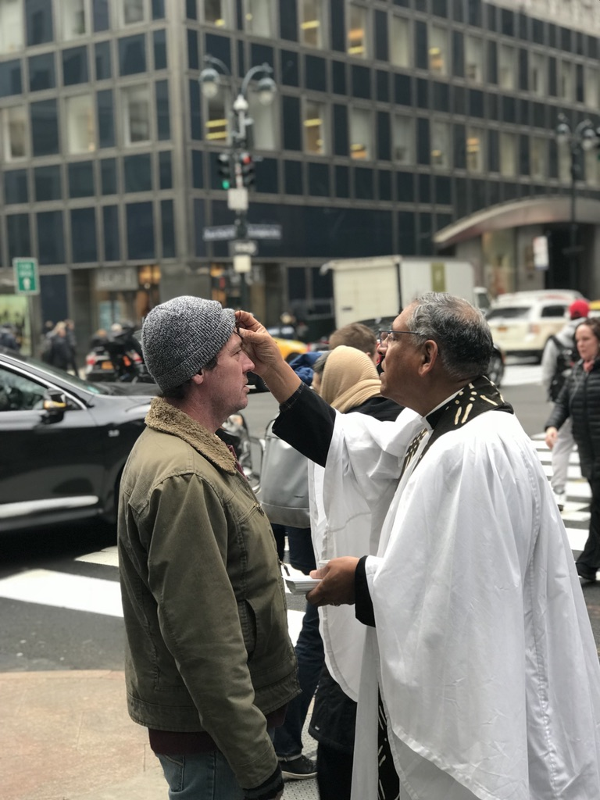
Ash Wednesday marks the beginning of Lent on March 5.

when those who, because of notorious sins, had been separated from the body of the faithful were reconciled by penitence and forgiveness, and restored to the fellowship of the Church (Book of Common Prayer, pp. 264-265).

The Episcopal Church invites us to observe Lent “by self-examination and repentance; by prayer, fasting, and self-denial; and by reading and meditating on God’s holy Word” (Book of Common Prayer, p. 265).
Ash Wednesday marks the beginning of Lent on March 5.

